Restore Medicaid Dental Coverage for Adults
Coalition to Fund Dental Access

and Include Dental Coverage for the Medicaid Expansion Population, Taking Advantage of the 100% Federal Match

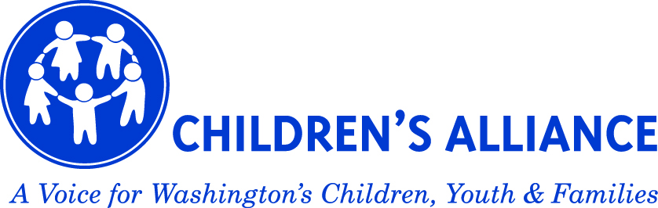
In 2011, dental coverage for most Medicaid-insured adults was eliminated. The same year funding was also cut for Community Health Centers to treat uninsured. As a result, nearly 450,000 low-income adults, including many people with disabilities and 130,000 seniors, were left with only access to emergency care.
REVISED COST-ESTIMATE: $30.8M state funds for the 13-15 biennium

Providing Dental Care Improves Health and Significantly Reduces Costs
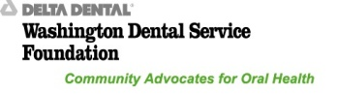
- Research has found that providing dental treatment to people with diabetes reduces their medical costs on average $3,200 per year and reduces hospitalizations by 61% in the first year of treatment
- More than 60,000 Medicaid-insured adults in WA have diabetes. If 25% receive dental care and this care results in just half of the medical cost savings cited in research, this could translate to
$24 million in savings.

Emergency Room Visits for Dental are Costly, Do Not Fix the Problem
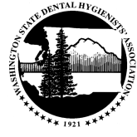
- The #1 reason the uninsured visit the ER is dental problems, yet ERs provide primarily pain relief and antibiotics, NOT the treatment needed to address the underlying dental condition
- Over 18 months, 54,000 dental-related ER visits cost over $36 million.

Poor Oral Health Can Negatively Impact Employability and Productivity
- Employed adults lose more than 164 million hours of work each year due to oral health problems

Untreated Oral Disease Can Have Serious Health Consequence
- Untreated gum disease can exacerbate diabetes leading to costly medical complications (heart disease, renal disease, amputations)
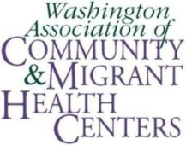
- Gum disease is also linked to heart disease, stroke, and pneumonia
- Oral disease can cause the body to reject medically necessary organ transplants such as heart, lung, or kidney
- The longer oral disease goes untreated, the higher the risk for complications

Seniors and people with disabilities are especially at risk
- Nearly 1 in 3 low-income seniors have a dental problem that needs to be addressed in the next month
ELDERCARE ALLIANCE
Without Access to Dental Care, Patients and the
Healthcare System Suffer
In the worst cases, dental decay can be life threatening, said Dr. Brian Hoyt, Medical Director of the Emergency Department at PeaceHealth St. John Medical Center in Longview. The infection spreads into the gums and into the throat and can obstruct the patient’s breathing or cause meningitis.
“We’re spending two, three or even four times the amount to treat these patients on an emergency basis, instead of focusing on the preventative care to avoid the problems in the first place,” Dr. Hoyt said.

For more information, please contact:
AARP: Ingrid McDonald (206) 330-6531
Children’s Alliance: Jennifer Estroff (509-859-2012)
NW Health Law Advocates: Daniel Gross (206-325-6464)
PH Seattle-King Co: Jennifer Muhm (206-263-8813), Genesee Adkins (206-263-9628)
Solid Ground/Poverty Action Network: Tony Lee (206-795-9110) , Kate Baber (206-669-5524)
University of Washington School of Dentistry: Steve Steinberg (206-616-0827)
Washington Association of Community & Migrant Health Centers: Shirley Prasad (360-786-9722,x227), Kate White Tudor (360-402-1272)

Washington Dental Service Foundation: Cindi Holmstrom (360-870-2729), Diane Oakes (206-528-2373)
Washington Denturist Association: Carolyn Logue (360-789-3491)
Washington State Dental Association: David Michener (360-956-0909), Linda Hull (360-352-4980), Bracken Killpack (206-973-5227)
Washington State Dental Hygienists Association: Melissa Johnson (360-280-6429)
Washington State Society of Oral and Maxillofacial Surgeons: Susie Tracy (360-701-4089)

Tammy Alsby, a nurse and the interim emergency department manager at Valley General Hospital in Monroe, sees patients come into the emergency room with dental problems every day.
The patients are desperate. They have no dental insurance through the state, and they can’t afford to pay for dental care themselves. They have deep infections and heavy pain but there is not much that Valley General physicians can do except give the patients antibiotics and temporarily numb the area of the mouth that hurts the most.

Kelly was in pain for five years from two cracked teeth suffered in a car accident. The 49-year-old mother and foster mother from eastern Washington has been on and off Medicaid, has no dental coverage and was forced to pay out of pocket to get both teeth pulled. She still lives in fear that more dental problems will come. She's a diabetic, still suffers from tooth pain and is just waiting for the next shoe to drop. "People need help. I just don’t have the funds for dental care."

